**Exercise No:10**

**Date:21/11/2020**

**Aim:** Write a Python function that accepts a string and calculate the number of upper case letters and lower case letters

**Program:**

def string_test(s):

d={"UPPER_CASE":0, "LOWER_CASE":0}

for i in range(len(s)):

if(s[i].isupper()):

d["UPPER_CASE"]+=1

elif(s[i].islower()):

d["LOWER_CASE"]+=1

print("No. of Upper case characters:",d["UPPER_CASE"])

print("No. of Lower case characters:",d["LOWER_CASE"])

s=input()

p=string_test(s)

**Link:**

[**http://103.53.53.18/mod/vpl/forms/edit.php?id=325&userid=1782#**](http://103.53.53.18/mod/vpl/forms/edit.php?id=325&userid=1782)

**Output:**

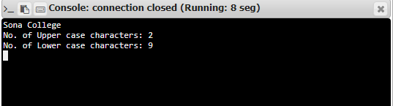

**Result:**

The program was executed successfully and the output was verified.